

Subject Code: EEET1368

Student Name: Aditya Prawira

RMIT ID: S3859061

Assignment Title: Mid-semester Assignment

Due date: April 16th, 2021

# Part 1

PI controller is desired to be implemented into a closed-loop system to regulate fluid level inside the water tank. The closed-loop system will take flow rate as an input which is represented a unit step-point signal $r\left(t\right)=R_{0}=1$. On the other hand, the closed-loop system will produce output signal for the fluid level inside the tank represented as $y(t)$. The transfer function that represent the level control of the water tank system is denoted as

$$G\left(s\right)= \frac{0.01}{10s+1}$$

The parameters provided for the system is that the desired closed-loop polynomial will be in form of $s^{2}+2ξω_{n}s + ω_{n}^{2}$, where the camping coefficient and natural frequency are set to be $ξ=0.707$, and $ω_{n}=1 rad/s$.

Now, let’s convert the transfer function of the system to have form of

$$G\left(s\right)= \frac{b}{s+a}$$

Therefore,

$$G\left(s\right)=\frac{b}{s+a}=\frac{0.001}{s+0.1}, where a=0.1, and b=0.001$$

Now, the expected PI controller would be in form of

$$C\left(s\right)= K_{c}\left(1+ \frac{1}{τ_{I}s}\right)$$

Where the general form of the controller would be represented as

$$C\left(s\right)= \frac{c_{1}s+ c_{0}}{s}$$

Then,

$$K_{c}=c_{1}$$

$$\frac{K_{c}}{τ_{I}}=c_{0}⟹ τ_{I}= \frac{K_{c}}{c_{0}}$$

Now, to calculate the actual closed-loop system

$$T_{cl}\left(s\right)= \frac{G(s)C(s)}{1+G(s)C(s)}$$

Therefore, let’s calculate $G(s)C(s)$ to simplify the rest of the calculation.

$$G\left(s\right)C\left(s\right)=\left(\frac{b}{s+a}\right)\left(\frac{c_{1}s+ c_{0}}{s}\right)$$

$$G\left(s\right)C\left(s\right)=\frac{b(c_{1}s+ c_{0})}{s(s+a)}$$

Therefore,

$$T_{cl}\left(s\right)= \left(\frac{b(c_{1}s+ c_{0})}{s(s+a)}\right)\left(\frac{s(s+a)}{s\left(s+a\right)+ b(c_{1}s+ c_{0}) }\right)$$

$${∴ T}_{cl}\left(s\right)= \left(\frac{b(c_{1}s+ c_{0})}{s\left(s+a\right)+ b(c_{1}s+ c_{0})}\right)$$

From this point, equate the denominator of $T_{cl}(s)$ with the desired polynomial of the closed-loop system.

$$∴ s\left(s+a\right)+ b\left(c_{1}s+ c_{0}\right)= s^{2}+2ξω_{n}s + ω_{n}^{2}$$

$$⟹ s^{2}+\left(a+bc_{`1}\right)s + bc_{0}= s^{2}+2ξω_{n}s + ω_{n}^{2}$$

By coefficient parameters are able to be found as

$$s:a+bc_{1}=2ξω_{n} ⟹ c_{1}= \frac{2ξω_{n}-a}{b}$$

$$constant:bc_{0}=ω_{n}^{2} ⟹ c_{0}= \frac{ω_{n}^{2}}{b}$$

By the fact that the value of $a=0.1$, $b=0.001$, $ξ=0.707$, and $ω_{n}=1 rad/s$, Let’s implement FirstOrderPI.m class top find the value of $K_{c}$, and $τ_{I}$.

%% Created by: Aditya Prawira

% RMIT ID: S3859061

classdef FirstOrderPI

properties

Kc; tauI;

Cs; P; I;

end

methods

function obj = FirstOrderPI(wn, zeta, a, b)

c1 = (2*zeta*wn - a)/b;

c0 = wn^2 / b;

obj.Kc = c1;

obj.tauI = c1/c0;

obj.Cs = tf([c1 c0], [1 0]);

obj.P = obj.Kc;

obj.I = obj.Kc/obj.tauI;

end

end

end

**Figure 1.** FirstOrderPI.m custom MATLAB class

**Figure 2.** params1.m MATLAB program that generate parameters for SIMULINK simulation.

%% Created by: Aditya Prawira

% RMIT ID: S3859061

clear

clc

close all

a = 0.1; b = 0.001;

zeta = 0.707; wn = 1;

time = 20;

Gs = tf(b, [1 a]);

pi = FirstOrderPI(wn, zeta, a, b);

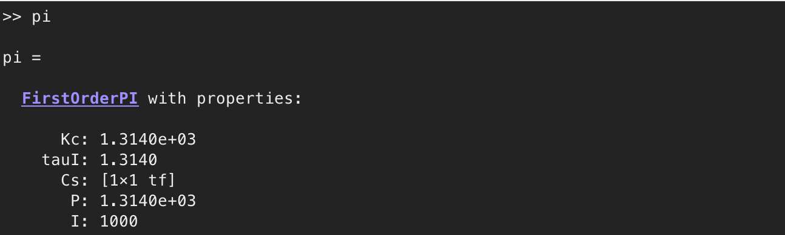

**Figure 3.** Parameters generated by utilising FirstOrderPI.m MATLAB class.

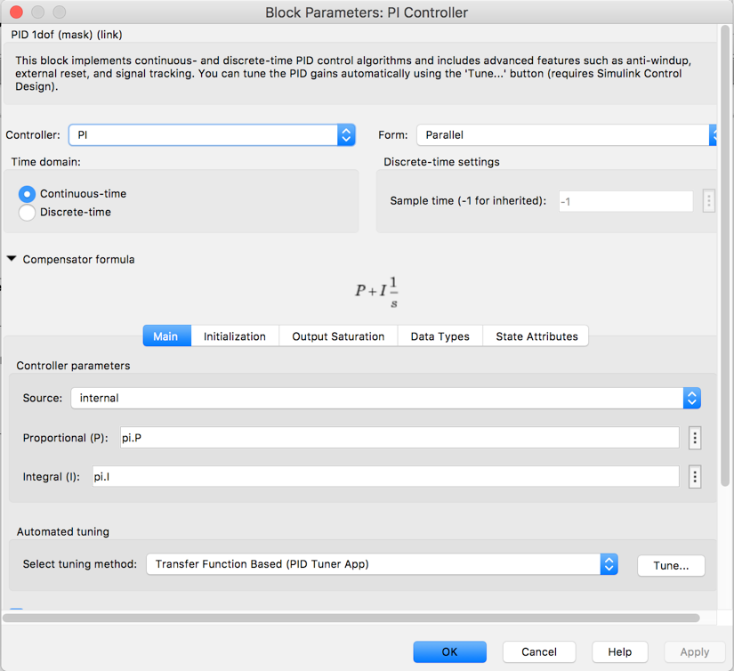

**Figure 4.** PI controller configuration.

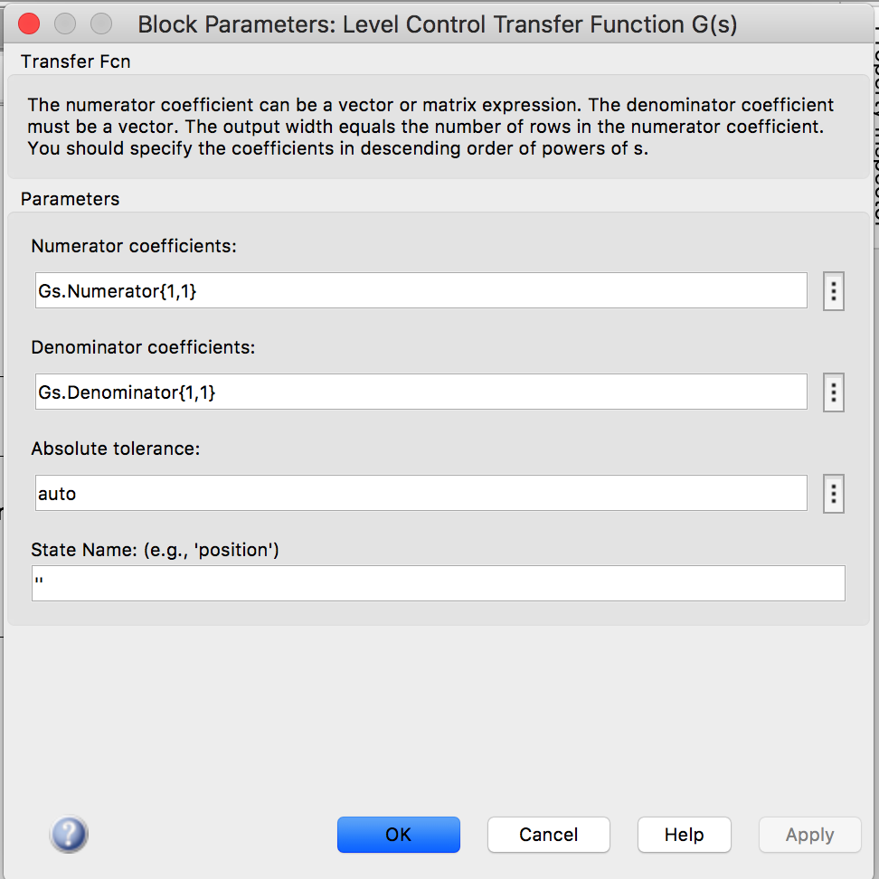

**Figure 4.** Level control transfer function configuration

The simulation will utilize simulation time of 20 seconds, and sampling interval of $∆t=0.1s$.

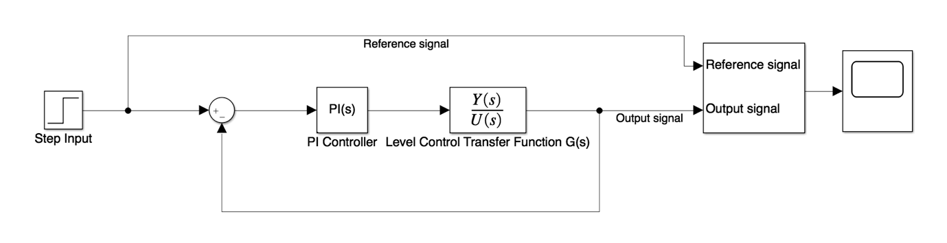

**Figure 5.** Simulink diagram of the simulation (sim1.slx)

By running params1.m file and run sim1.slx the output of the simulation will produced as shown below.



**Figure 3.** Closed-loop system plot of output and reference signal

As what has been shown in the plot there will be an overshoot around ~ 1.18, and will eventually reaches the value of the step response amplitude since it is proven by final value theorem that

$$\lim_{t→∞}{y\left(t\right)=\lim_{s→0}{sY\left(s\right)=R_{0}}}$$

The system is produce an acceptable stability and response speed which is accepted as a good response.

# Part 2

($λ=1$)

$$G\left(s\right)= \frac{K_{p}e^{-ds}}{(τ_{p}s+1)}≈\frac{K_{p}(-ds+2)}{(τ_{p}s+1)(ds+2)}$$

$$G\left(s\right)= \frac{0.5e^{-6s}}{(s+1)}≈\frac{0.5\left(-6s+2\right)}{\left(s+1\right)\left(6s+2\right)}=\frac{-\frac{1}{2}s+ \frac{1}{6}}{(s+1)(s+ \frac{1}{3})}$$

Model based PID,

$$G\left(s\right)=\frac{-\frac{1}{2}s+ \frac{1}{6}}{(s+1)(s+ \frac{1}{3})}= \frac{b_{1}s+ b_{0}}{(s+ α_{1})(s+ α_{2})}$$

$$τ_{p}=1, d=6$$

$$if\left(\frac{1}{τ_{p}}> \frac{2}{d}\right) ⇒ \left(α_{1}= \frac{2}{d}\right)⋀\left(α_{2}= \frac{1}{τ_{p}}\right)$$

$$if\left(\frac{1}{τ_{p}}< \frac{2}{d}\right) ⇒ \left(α_{1}= \frac{1}{τ_{p}}\right)⋀\left(α_{2}= \frac{2}{d}\right)$$

Therefore, $$α_{1}= \frac{1}{3}, {\& α}_{2}=1$$

Assuming the general form of PID controller transfer function of

$$C\left(s\right)= \frac{c_{2}s^{2}+c_{1}s+ c_{0}}{s(s+ I_{0})}$$

Now calculate the actual closed-loop transfer function

$$T_{cl}\left(s\right)= \frac{G(s)C(s)}{1+G(s)C(s)}$$

calculate $G(s)C(s)$ to simplify the rest of the calculation.

$$G\left(s\right)C\left(s\right)=\left(\frac{b_{1}s+ b_{0}}{(s+ α_{1})(s+ α_{2})}\right)\left(\frac{c_{2}s^{2}+c_{1}s+ c_{0}}{s(s+ I_{0})}\right)=\left(\frac{b_{1}s+ b_{0}}{(s+ α_{1})(s+ α_{2})}\right)\left(\frac{c_{2}(s+γ_{1} )(s+ α_{2})}{s(s+ I_{0})}\right)= \frac{{ b}_{1}s+ b_{0}}{s(s+ α_{1})(s+ I_{0})}$$

Now, we need to equate the denominator with the desired closed-loop polynomial,

$$s\left(s+ α_{1}\right)\left(s+ I_{0}\right)=(s^{2}+2ξω_{n}s + ω_{n}^{2})(s+ λ)$$

Then, by coefficient parameters for the general form of the PID controller can be found as

$$I_{0}= -c_{2}b_{1}+2ξω_{n}+ λ- α_{1}$$

$$c_{2}= \frac{-2ξω_{n}α_{1}- λα_{1}+ α_{1}^{2}+ω_{n}^{2}+2λξω_{n}- \left(\frac{b_{1}λω_{n}^{2}}{b_{0}}\right)}{b_{0}- α_{1}b_{1}}$$

$$γ_{1}= \frac{λω_{n}^{2}}{b_{0}c_{2}}$$

Now, equate the general form of the PID controller transfer function with the expanded version of it.

$$C\left(s\right)= \frac{c_{2}s^{2}+c_{1}s+ c_{0}}{s(s+ I_{0})}=\frac{c_{2}(s+γ_{1} )(s+ α_{2})}{s(s+ I_{0})}$$

Therefore,

$$c_{1}= c_{2}\left(γ_{1}+ α_{2}\right), and c_{0}=c_{2}α_{2}γ_{1}$$

Then compare it with the standard PID controller form, then parameters for the controller can be as shown below.

$$τ_{f}= \frac{1}{I_{0}}$$

$$τ_{I}= \frac{c_{1}}{c_{2}}- τ_{f}$$

$$K_{c}= τ_{I}τ_{f}c_{0}$$

$$τ_{D}= \frac{c_{2}τ_{I}τ_{f}- K_{c}τ_{I}τ_{f}}{K_{c}τ_{I}}$$

The ModelPID.m class as shown below will be utilized to produce the required parameters of the design

%% Created by: Aditya Prawira

% RMIT ID: S3859061

classdef ModelPID

properties

Kc;

tauI; tauD; tauF;

P; D; I; N;

end

methods

function obj = ModelPID(a1, a2, b0, b1, damp_coeff, wn, lambda)

c2 = (-2*damp_coeff*wn*a1 - lambda*a1 + a1^2 + wn^2 + ...

2*lambda*damp_coeff*wn - (b1*lambda*wn^2/b0))/(b0 - a1*b1);

gamma = (lambda*wn^2)/(b0*c2);

I0 = -c2*b1 + 2*damp_coeff*wn + lambda - a1;

c1 = c2*(gamma + a2);

c0 = c2*a2*gamma;

obj.tauF = 1/I0;

obj.tauI = (c1/c0) - obj.tauF;

obj.Kc = obj.tauI*obj.tauF*c0;

obj.tauD = (c2*obj.tauI*obj.tauF -obj.Kc*obj.tauI*obj.tauF)/(obj.Kc*obj.tauI);

obj.P = obj.Kc;

obj.I = obj.Kc/obj.tauI;

obj.D = obj.Kc*obj.tauD;

obj.N = 1/(obj.tauF);

end

end

end

**Figure 4.** ModelPID.m MATLAB class.

%% Created by: Aditya Prawira

% RMIT ID: S3859061

clear

clc

close all

% Global variable

time = 100;

half_time = time/2;

lambda = 1;

a1 = 1/3;

a2 = 1;

b1 = -1/2;

b0 = 1/6;

Gs = tf(0.5, [1 1]);

damp_coeff = 0.707;

damp_coeff2 = 1;

beta = 0.1;

wn = 0.19;

pid = ModelPID(a1, a2, b0, b1, damp_coeff, wn, lambda);

D = tf([pid.Kc*pid.tauD 0], [pid.tauF 1]);

pid2 = ModelPID(a1, a2, b0, b1, damp_coeff2, wn, lambda);

D2 = tf([pid2.Kc*pid2.tauD 0], [pid.tauF 1]);

**Figure 4.** params2.m MATLAB program.

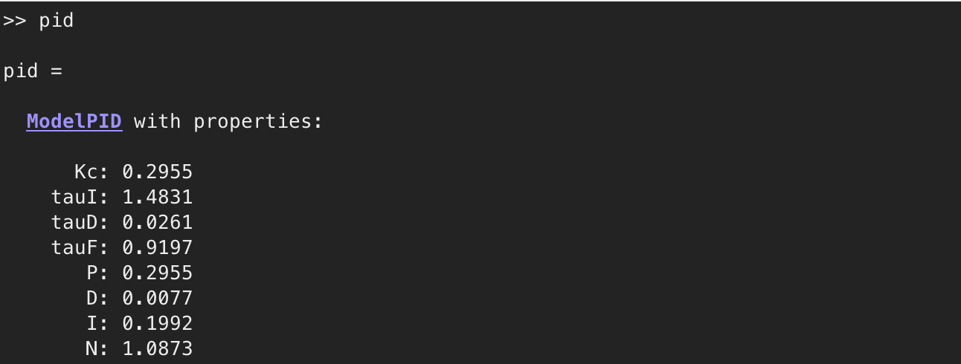

**Figure 4.** Parameters generated by utilising ModelPID.m MATLAB class.

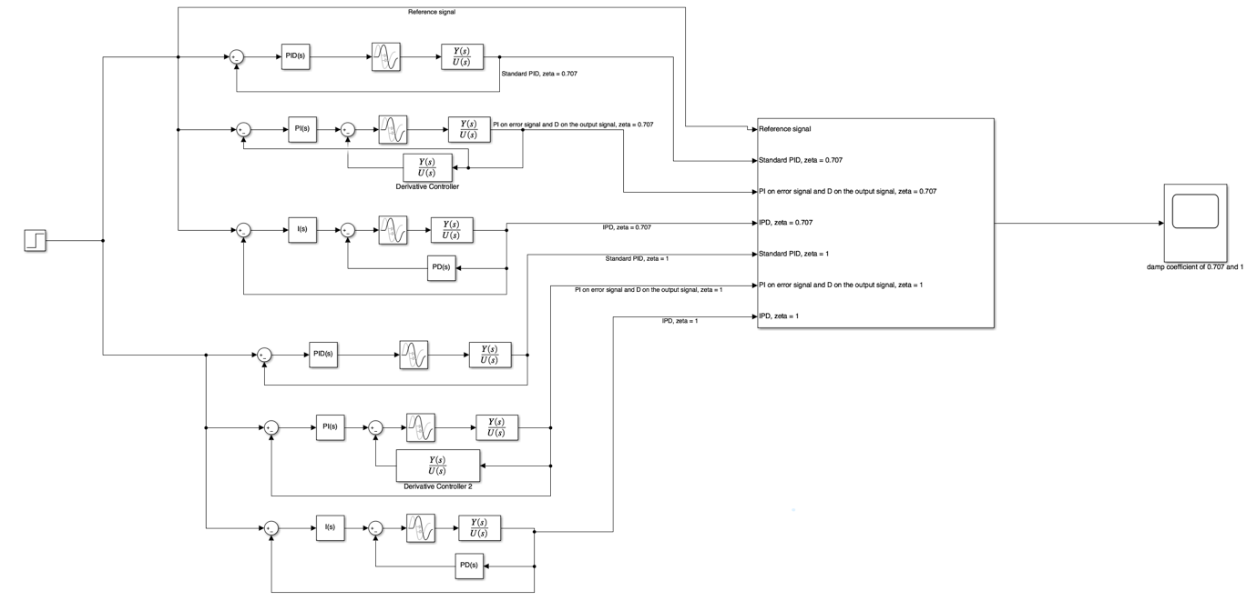

**Figure #.** Simulink diagram of the simulation.

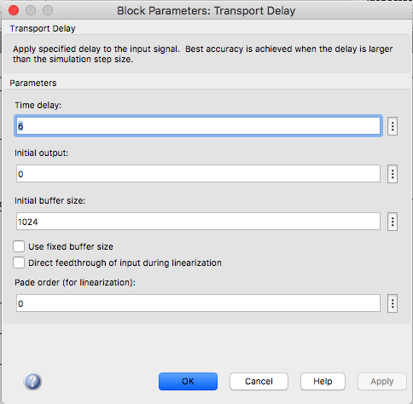

**Figure #.** Configuration of transport delay for Simulink simulation.

# 

**Figure #.** Response of poles at 1



**Figure #.** Response of poles at 1/2

# Part 3

An underdamped mechanical system is being introduced in this particular task. The system, introduced, has been severely underdamped with an unstable zero. For this particular system, the transfer of the system is expressed by

$$G\left(s\right)= \frac{-s+1}{(s^{2}+0.2s+10)}$$

The closed-loop system of the mechanical system will take input voltage and will produce output of the vibration speed. Then, a PID controller is desired to control the mechanical system. However, applying pole cancellation approach that has been done on the previous task won’t be applicable for the current task as the system is oscillatory. Hence, general PID design technique is required to solve the current problem, and it is known that closed-loop poles are all positioned at -10 ($λ=10$). Now, let’s consider the general form of the PID controller transfer function expressed as

$$C\left(s\right)= \frac{c_{2}s^{2}+c_{1}s+ c_{0}}{s(s+ I_{0})}$$

Then, the model based of the plant transfer function (transfer function of the mechanical system) will have the general form of

$$G\left(s\right)=\frac{-s+1}{(s^{2}+0.2s+10)} = \frac{b_{1}s+ b_{0}}{s^{2}+a_{1}s+a_{0}}$$

Therefore, parameters can be found where $b_{1}=-1, b_{0}=1, a_{1}=0.2$, and ${ a}_{0}=10$. Proceeding to the next method, the desired closed-loop polynomial is expressed as

$$A_{cl}\left(s\right)=\left(s^{2}+2ξω_{n}s + ω_{n}^{2}\right){\left(s+ λ\right)}^{2}$$

Where $0< ξ<1$ and $ω_{n} ≤ λ$. However, let $A_{cl}\left(s\right)= {{s^{4}+ t}_{3}s}^{3}+ t_{2}s^{2}+t_{1}s+t_{0}$ to simplify the calculation. Therefore, let’s calculate the actual closed-loop transfer function which is represented as

$$T_{cl}\left(s\right)= \frac{G(s)C(s)}{1+G(s)C(s)}$$

Since, only the denominator $T_{cl}\left(s\right)$ is required to be equated with $A_{cl}\left(s\right)$, let’s compute

$$1+G\left(s\right)C\left(s\right)= 0$$

Which is the method to find pole of $T_{cl}\left(s\right)$. Therefore,

$$1+G\left(s\right)C\left(s\right)= 0$$

$$1+\left(\frac{b_{1}s+ b_{0}}{s^{2}+a_{1}s+a_{0}}\right)\left(\frac{c_{2}s^{2}+c_{1}s+ c_{0}}{s(s+ I_{0})}\right)= 0$$

$$⟹\frac{s\left(s+ I_{0}\right)(s^{2}+a_{1}s+a_{0})}{s\left(s+ I_{0}\right)(s^{2}+a_{1}s+a_{0})}+\left(\frac{b_{1}s+ b_{0}}{s^{2}+a_{1}s+a_{0}}\right)\left(\frac{c_{2}s^{2}+c_{1}s+ c_{0}}{s(s+ I_{0})}\right)= 0$$

$$⟹s\left(s+ I_{0}\right)(s^{2}+a_{1}s+a_{0})+(b_{1}s+ b_{0})(c_{2}s^{2}+c_{1}s+ c_{0})= 0$$

$$⟹s^{4}+\left(b_{1}c_{2}+ a_{1}+I_{0}\right)s^{3}+\left(b_{1}c_{1}+ b_{0}c_{2}+a_{0}+ a_{1}I_{0}\right)s^{2}+\left(b_{1}c_{0}+ b_{0}c_{1}+ I_{0}a_{0}\right)s+ b_{0}c_{0}= 0$$

$$∴Equate$$

$$s^{4}+\left(b_{1}c_{2}+ a_{1}+I_{0}\right)s^{3}+\left(b_{1}c_{1}+ b_{0}c_{2}+a_{0}+ a_{1}I_{0}\right)s^{2}+\left(b_{1}c_{0}+ b_{0}c_{1}+ I_{0}a_{0}\right)s+ b_{0}c_{0}= {{s^{4}+ t}_{3}s}^{3}+ t_{2}s^{2}+t_{1}s+t_{0}$$

This can be simplified or solved by using matrix operation method. Therefore,

$$∴\left[\begin{matrix}1 & b_{1} & 0 & 0 \\ a_{1} & b_{0} & b_{1} & 0 \\ a_{0} & 0 & b_{0} & b_{1} \\ 0 & 0 & 0 & b_{0}\end{matrix}\right]\left[\begin{aligned}\begin{matrix}I_{0} \\ c_{2} \\ c_{1}\end{matrix} \\ c_{0}\end{aligned}\right]= \left[\begin{aligned}\begin{matrix}t_{3}- a_{1} \\ t_{2}- a_{0} \\ t_{1}\end{matrix} \\ t_{0}\end{aligned}\right]$$

$$⟹\left[\begin{aligned}\begin{matrix}I_{0} \\ c_{2} \\ c_{1}\end{matrix} \\ c_{0}\end{aligned}\right]={\left[\begin{matrix}1 & b_{1} & 0 & 0 \\ a_{1} & b_{0} & b_{1} & 0 \\ a_{0} & 0 & b_{0} & b_{1} \\ 0 & 0 & 0 & b_{0}\end{matrix}\right]}^{-1} \left[\begin{aligned}\begin{matrix}t_{3}- a_{1} \\ t_{2}- a_{0} \\ t_{1}\end{matrix} \\ t_{0}\end{aligned}\right]$$

Since, it is known that

$$\left(s^{2}+2ξω_{n}s + ω_{n}^{2}\right){\left(s+ λ\right)}^{2}= {{s^{4}+ t}_{3}s}^{3}+ t_{2}s^{2}+t_{1}s+t_{0}$$

Therefore, $t_{3}, t_{2}, t_{1}$, and $t_{0}$ can be solved.

$$t_{3}=2(ξω_{n}+λ)$$

$$t_{2}=4ξω_{n}λ+ ω_{n}^{2}+λ^{2}$$

$$t_{1}=2ω_{n}λ(ξλ+ ω_{n})$$

$$t_{0}=ω_{n}^{2}λ^{2}$$

Since,

$$τ_{f}= \frac{1}{I_{0}}$$

$$τ_{I}= \frac{c_{1}}{c_{2}}- τ_{f}$$

$$K_{c}= τ_{I}τ_{f}c_{0}$$

$$τ_{D}= \frac{c_{2}τ_{I}τ_{f}- K_{c}τ_{I}τ_{f}}{K_{c}τ_{I}}$$

Therefore, let’s apply those calculation on MATLAB. Below, is the PID.m MATLAB class utilized for the is simulation.

%% Created by: Aditya Prawira

% RMIT ID: S3859061

classdef PID

properties

Kc;

tauI; tauD; tauF;

P; D; I; N;

end

methods

function obj = PID(I0, c2, c1, c0)

obj.tauF = 1/I0;

obj.tauI = (c1/c0) - obj.tauF;

obj.Kc = obj.tauI*obj.tauF*c0;

obj.tauD = (c2*obj.tauI*obj.tauF - obj.Kc*obj.tauI*obj.tauF)...

/(obj.Kc*obj.tauI);

obj.P = obj.Kc;

obj.I = obj.Kc/obj.tauI;

obj.D = obj.Kc*obj.tauD;

obj.N = 1/(obj.tauF);

end

end

end

**Figure #.** PID.m MATLAB class

%% Created by: Aditya Prawira

% RMIT ID: S3859061

clear

clc

close all

% Simulation Parameter

time = 10;

disturbance_time = 3;

input_amplitude = 1;

input_disturbance_amplitude = -3;

% Plant transfer function numerator parameters

b1 = -1;

b0 = 1;

% Plant transfer function numerator parameters

a1 = 0.2;

a0 = 10;

% Choose zeta < 1 for underdamped condition

zeta = 0.707;

wn = 10;

delta_t = 1/5*wn;

% Poles of closed-loop

lambda = 10;

t3 = 2*(zeta*wn + lambda);

t2 = 4*zeta*wn*lambda + wn^2 + lambda^2;

t1 = 2*wn*lambda*(zeta*wn + wn);

t0 = wn^2 * lambda^2;

% Plant transfer function

Gs = tf([b1 b0], [1 a1 a0]);

Sy = [1 b1 0 0; a1 b0 b1 0; a0 0 b0 b1; 0 0 0 b0];

Acl = [t3 - a1; t2 - a0; t1; t0];

params = (num2cell(Sy\Acl));

[I0, c2, c1, c0] = params{:};

pid = PID(I0, c2, c1, c0);

D = tf([pid.Kc*pid.tauD 0], [pid.tauF 1]);

**Figure #.** Params3.m MATLAB program

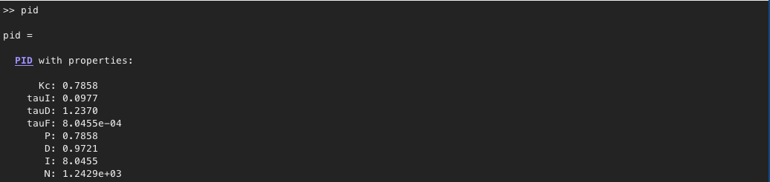

**Figure #.** Parameters generated by utilising PID.m MATLAB class.

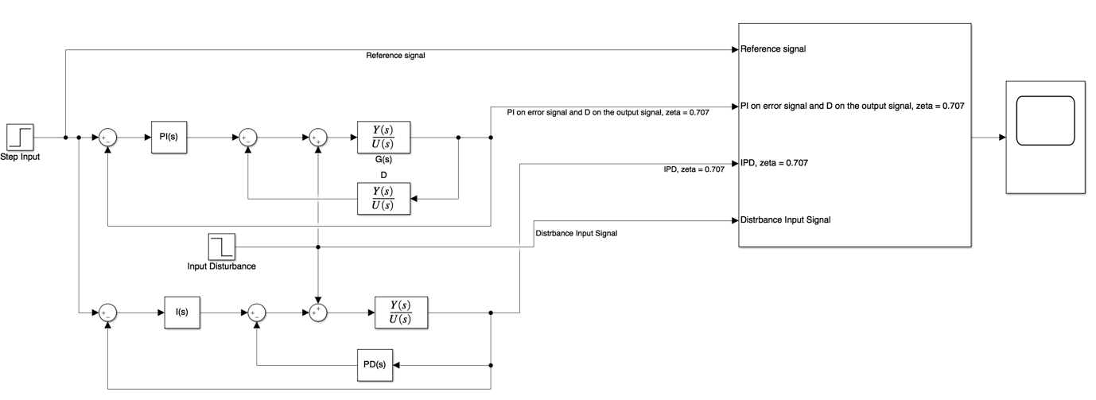

**Figure #.** Simulink diagram of task 3



**Figure #.** Simulation of task 3

# Part 4

Robot arm has been introduced for this task, where the system is being represented as a transfer function of

$$G\left(s\right)= \frac{10}{(0.1s+s)s}$$

A resonant controller is desired so that it allows the robot arm to keep track of the sinusoidal reference signal of $r\left(t\right)= R_{m}sin\left(ω_{0}t+ θ_{0}\right)= 3sin\left(ω_{0}t\right)$, as $ω_{0}= \sqrt{2}$. It is also known that poles of the closed-loop system are all positioned at -8 ($λ=8$). For this particular case, pole-assignment approach will be utilized to find the parameter of the resonant controller which is expressed by

$$C\left(s\right)=\frac{c_{2}s^{2}+c_{1}s+ c_{0}}{s^{2}+ω_{0}^{2}} = \frac{P(s)}{L(s)}$$

Now, let’s change the form of the plant’s transfer function to be in form of

$$G\left(s\right)= \frac{10}{(0.1s+s)s}= \frac{100}{(s+10)s}$$

The pole of the transfer function is then located at $s_{1}= -10, s_{2}=0$. Since the pole at zero has the most dominance, then let s = 0 for the weakest pole.

$$∴G\left(s\right)= \frac{100}{(0+10)s}= \frac{10}{s}$$

From here, it is known that the general form of the transfer function is to be represented as

$$G\left(s\right) =\frac{b}{s+a}= \frac{B(s)}{A(s)}$$

Therefore, $a=0$, and $b=10$. The desired polynomial of the closed-loop system is presented as

$$A_{cl}\left(s\right)=\left(s^{2}+2ξω_{n}s + ω_{n}^{2}\right)\left(s+ λ\right)$$

Where $0< ξ<1$ and $ω_{n} ≤ λ$, and by let $A_{cl}\left(s\right)= s^{3}+ t_{2}s^{2}+t_{1}s+t_{0}$. Now, let’s equate the denominator of the actual closed-loop transfer function with the desired polynomial. This process can be computed by

$$L\left(s\right)A\left(s\right)+P\left(s\right)B\left(s\right)= A_{cl}\left(s\right)$$

$$⟹(s^{2}+ω_{0}^{2})(s+a)+(c_{2}s^{2}+c_{1}s+ c_{0})b= A_{cl}\left(s\right)$$

Since, $a=0$, and $b=10$

$$∴(s^{2}+ω_{0}^{2})(s)+(c_{2}s^{2}+c_{1}s+ c_{0})10= s^{3}+ t_{2}s^{2}+t_{1}s+t_{0}$$

$$⟹s^{3}+10c_{2}s^{2}+\left(ω_{0}^{2}+10c_{1}\right)s+10c_{0}= s^{3}+ t_{2}s^{2}+t_{1}s+t_{0}$$

Hence,

$$c_{2}= \frac{t_{2}}{10}, c_{1}= \frac{t_{1}- ω_{0}^{2}}{10}, c_{0}= \frac{t_{0}}{10}$$

Where,

$$t_{2}=2ξω_{n}+ λ$$

$$t_{1}=ω_{n}(ω_{n}+2ξλ)$$

$$t_{0}= ω_{n}^{2}λ$$

Therefore, the derivation above now can be implemented in MATLAB to generate parameters required for the simulation.

%% Created by: Aditya Prawira

% RMIT ID: S3859061

clc

clear

close all

Gs = tf(100, [1 10 0]);

Rm = 3;

w0 = sqrt(2);

lambda = 8;

a = 0; b = 10;

%% Parameters that can be changed %%

zeta = 0.707; % damping coefficient is expected to be less than 1

wn = 8; % natural frequency is expected to be wn <= lambda

sampling_time = 0.001;

simulation_time = 50;

%% Calculate parameters for resonant controller (Applying pole-assignment)

t2 = 2*zeta*wn + lambda;

t1 = wn*(wn + 2*zeta*wn);

t0 = wn^2 * lambda;

c2 = (t2 - a)/b;

c1 = (t1 - w0^2)/b;

c0 = (t0 - (a * w0^2))/b;

ResonantController = tf([c2 c1 c0], [1 0 w0^2]);

**Figure #.** resonant_params.m MATLAB program

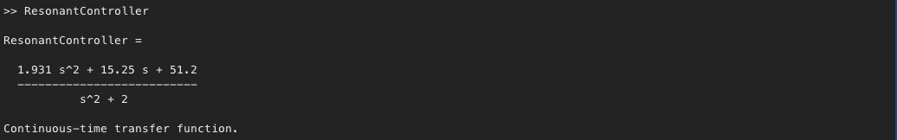

**Figure #.** Resonant controller transfer function generated from MATLAB program above on Figure #.

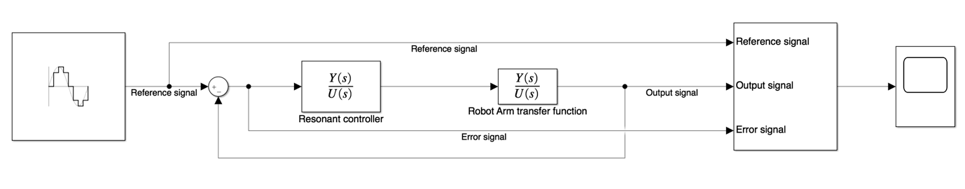

**Figure #.** Simulink diagram for task 4.



**Figure #.** Simulation of task 4

As what has been shown from the response, the error signal of the response is eventually reaches 0 as $t→∞$. Now, to prove this let’s utilize final value theorem, to show that

$$\lim_{t→∞}{e\left(t\right)=\lim_{s→0}{sE\left(s\right)=0}}$$

Now a closed loop response represented by the Simulink diagram in Figure #, it is known that

$$\frac{Y(s)}{R(s)}=\frac{G(s)C(s)}{1+G(s)C(s)}$$

$$⟹Y(s)=R(s)\left(\frac{G(s)C(s)}{1+G(s)C(s)}\right)$$

Now the Laplace transform of the reference signal is

$$R\left(s\right)= L\left\{r(t)\right\}= L\left\{3sin\left(ω_{0}t\right)\right\}=\frac{3ω_{0}}{s^{2}+ ω_{0}^{2}}$$

And

$$\frac{G(s)C(s)}{1+G(s)C(s)}=\frac{b(c_{2}s^{2}+c_{1}s+ c_{0})}{(s^{2}+ω_{0}^{2})(s+a)+(c_{2}s^{2}+c_{1}s+ c_{0})b}$$

$$∴Y\left(s\right)=R(s)\left(\frac{b(c_{2}s^{2}+c_{1}s+ c_{0})}{(s^{2}+ω_{0}^{2})(s+a)+(c_{2}s^{2}+c_{1}s+ c_{0})b}\right)$$

By the fact that

$$L\left\{e(t)\right\}= L\left\{r\left(t\right)-y(t)\right\}$$

$$⇒E\left(s\right)=R\left(s\right)-Y\left(s\right)$$

$$⇒E\left(s\right)=R\left(s\right)-R(s)\left(\frac{b(c_{2}s^{2}+c_{1}s+ c_{0})}{(s^{2}+ω_{0}^{2})(s+a)+(c_{2}s^{2}+c_{1}s+ c_{0})b}\right)$$

$$⇒E\left(s\right)=\frac{3ω_{0}}{s^{2}+ ω_{0}^{2}}\left(1- \frac{b(c_{2}s^{2}+c_{1}s+ c_{0})}{(s^{2}+ω_{0}^{2})(s+a)+(c_{2}s^{2}+c_{1}s+ c_{0})b}\right)$$

$$⇒E\left(s\right)=\frac{3ω_{0}}{s^{2}+ ω_{0}^{2}}\left( \frac{\left(s^{2}+ω_{0}^{2}\right)\left(s+a\right)+b\left(c_{2}s^{2}+c_{1}s+ c_{0}\right)- b(c_{2}s^{2}+c_{1}s+ c_{0})}{(s^{2}+ω_{0}^{2})(s+a)+(c_{2}s^{2}+c_{1}s+ c_{0})b}\right)$$

$$⇒E\left(s\right)=\frac{3ω_{0}}{s^{2}+ ω_{0}^{2}}\left( \frac{\left(s^{2}+ω_{0}^{2}\right)\left(s+a\right)}{(s^{2}+ω_{0}^{2})(s+a)+(c_{2}s^{2}+c_{1}s+ c_{0})b}\right)$$

$$⇒E\left(s\right)=\frac{3ω_{0}\left(s+a\right)}{(s^{2}+ω_{0}^{2})(s+a)+(c_{2}s^{2}+c_{1}s+ c_{0})b}$$

Since $a=0$, and $b=10$

$$∴E\left(s\right)=\frac{3ω_{0}s}{s(s^{2}+ω_{0}^{2})+10(c_{2}s^{2}+c_{1}s+ c_{0})}$$

Now,

$$\lim_{t→∞}{e\left(t\right)=\lim_{s→0}{sE\left(s\right)= \lim_{s→0}{s\left(\frac{3ω_{0}s}{s(s^{2}+ω_{0}^{2})+10(c_{2}s^{2}+c_{1}s+ c_{0})}\right)=0\left(\frac{0}{0+10c_{0}}\right)}}}=0$$

The response above has been proven by the final value theorem that

$$\lim_{t→∞}{e\left(t\right)=\lim_{s→0}{sE\left(s\right)=0}}$$